ARTICLE TITLE IN CAPITAL LETTERS
Student's name and surname
Study program
Teacher’s academic degree/position, name and surname
Institution

Annotation (up to 300 characters) briefly describes the essence of the article, defines an issue and the main results.
Keywords: the abstract contains 3-4 keywords from a new line, separated from each other by commas. Keywords should reflect the main thrust of the content of the article.
INTRODUCTION
Introduction (up to 1 page), which justifies the relevance and/or novelty of the topic/research, briefly presents the problem, indicates the purpose of the research, research objectives (numbered), research object and research methods.

Purpose of the research – ..........
Research objectives:
- ............
- ............
- ............
Research object – ..............
Research methods: ................
LITERATURE REVIEW
The main part, which summarizes theoretical knowledge, presents a review of scientific and professional literature. The article is prepared with the text editor Microsoft Office Word and submitted in .doc or .docx formats. A4 size page format margins: left – 3 cm; the right one - 1 cm; upper and lower - 2 cm each. The main text is written in Times New Roman font, size 12 pt; the interval between lines is single, two-way alignment is used; the indent of the first sentence of the paragraph is 1.5 cm; one line space (12 pt) is left before the title of the structural part of the article, and half a line space (6 pt) is left after it.
Tables and figures in the article (diagrams, graphs, maps, logos, schemes, photos, etc.) are numbered with Arabic numerals. Figures have their own numbering sequence, and tables have their own (e.g. an article may contain both Table 1 and Figure 1). The numbering is continuous and consistently continuing throughout the article.
The table number is written above the table in the right margin in main font, and the title is above the table, centered in relation to the margins and highlighted in bold, e.g.:
1 Table
Results of the research groups
S. No. | Groups | Result A | Result B | Result C
1. | Group X | 125.2 | 12.78 | 915
2. | Group Y | 79.5 | 10.05 | 1005
3. | Group Z | 139.5 | 13.00 | 98
The numbers in the column are aligned according to the place of the decimal point. The text must include a reference to a table, e.g. (Table 1). A single line space is left below the table (12 pt).
ANALYSIS OF THE RESEARCH RESULTS
The main part presents the research methodology, research data and results of the analysis. This part might consist of several sections, giving them separate titles. The sections of the main body are not numbered.
The title and number of the figure are centered and written below the figure, the title of the figure is highlighted, e.g.:
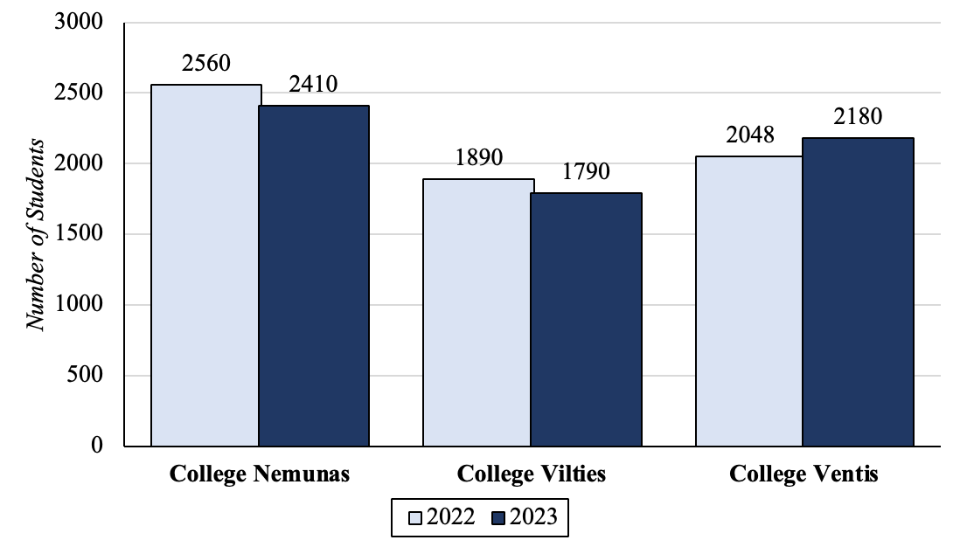
Fig. 1 Changes in the number of students in 2022-2023
The figure must be clear, and each of its elements must be clearly visible and legible. The optimal figure size is a third of the page. The text must include a reference to a figure, e.g. see Figure 1. A single line space is left before and after the figure.
CONCLUSIONS
Conclusions corresponding to the stated tasks (numbered):
- ............
- ............
- ............
LIST OF REFERENCES
List of information sources (numbered), prepared in APA style in accordance with the requirements for formalization of study papers of Panevėžio kolegija/State Higher Education Institution, see https://panko.lt/wp-content/uploads/2016/01/Studiju_rasto_darbu_iforminimo_reikalavimai_2024_01_26.pdf.
All listed information sources must be directly quoted, paraphrased or referenced in the article.
1. Abdelsamea, A., Hemayed, E., & Elazhary, H (2022). Virtual Machine Consolidation Challenges: A Review. International Journal of Innovation and Applied Studies, 8(4), 1504-1516. https://www.researchgate.net/publication/285692949_Virtual_Machine_Consolidation_Challenges_A_Review.
2. Bajdor, P. (2020). The Environmental Benefits of Cloud Computing. Proceedings of International Conference on Advanced Logistics & Transport, 273-278.
3. Cao, F., & Zhu, M. (2023). Energy Efficient Workflow Job Scheduling for Green Cloud. IEEE International Symposium on Parallel & Distributed Processing, Workshops and Phd Forum, 2218-2221.

ARTICLE TITLE IN ENGLISH
Summary is written in English (up to 1000 characters). A Lithuanian summary is provided for articles written in a foreign language.

